How to create EFS and how to mount all server.
1) create a EFS
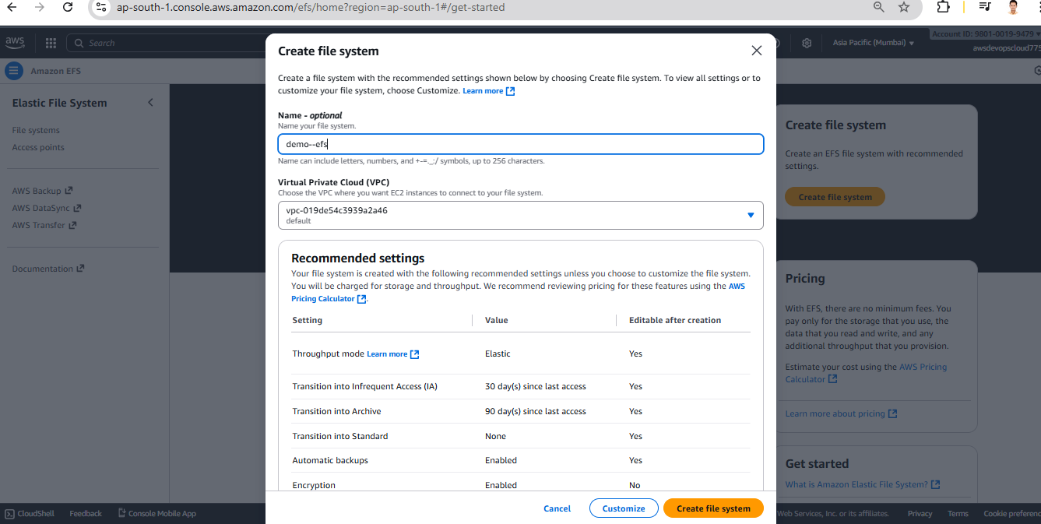

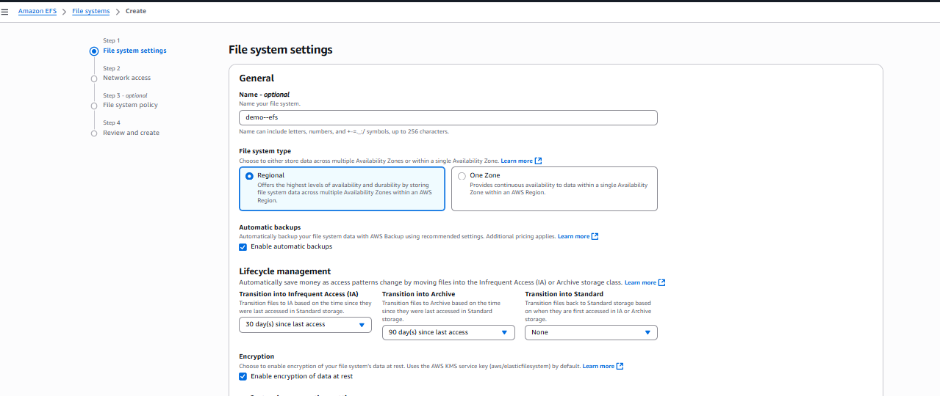
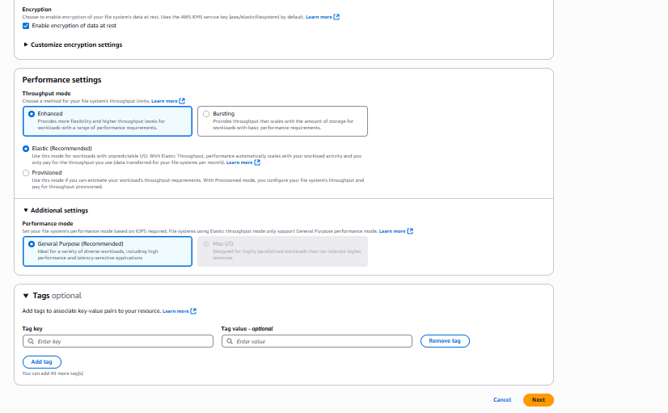
Here showing default security group but we don’t should be the default security group, so we need to create new security group
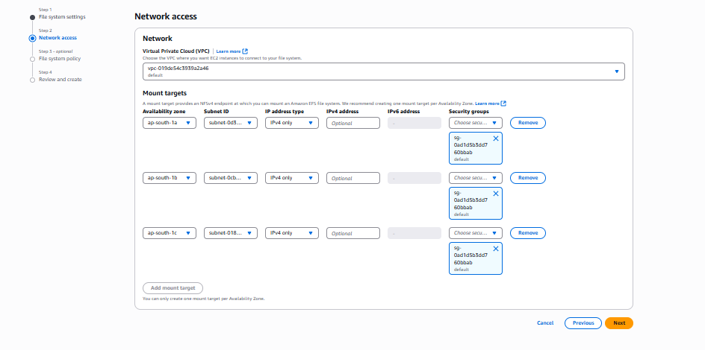
Create a security group
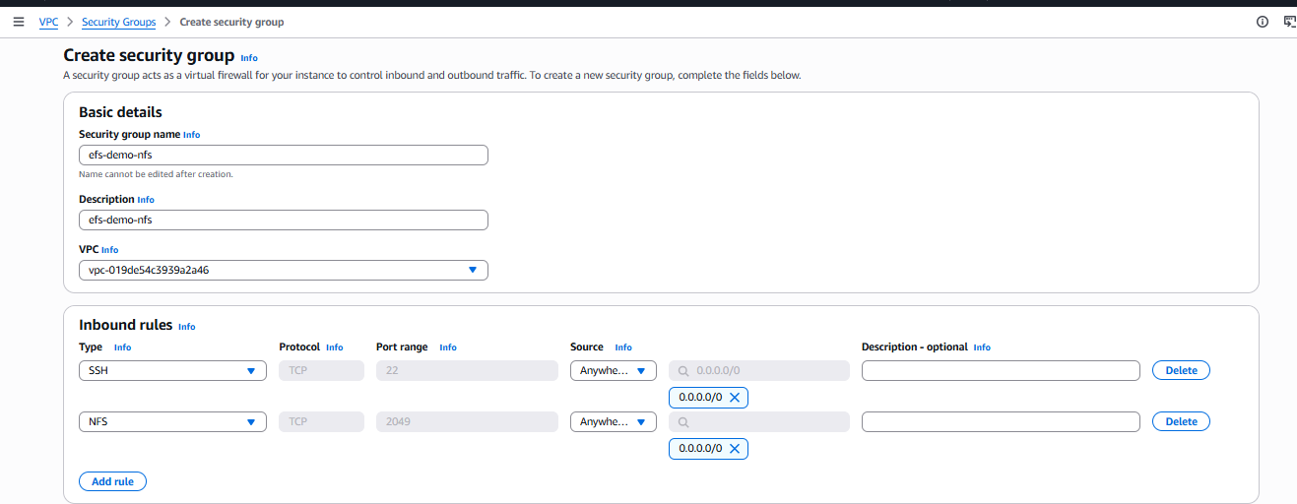
Security group created
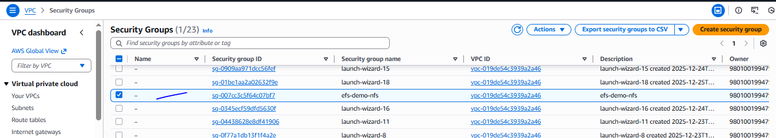
Added a custom security group while creating EBS
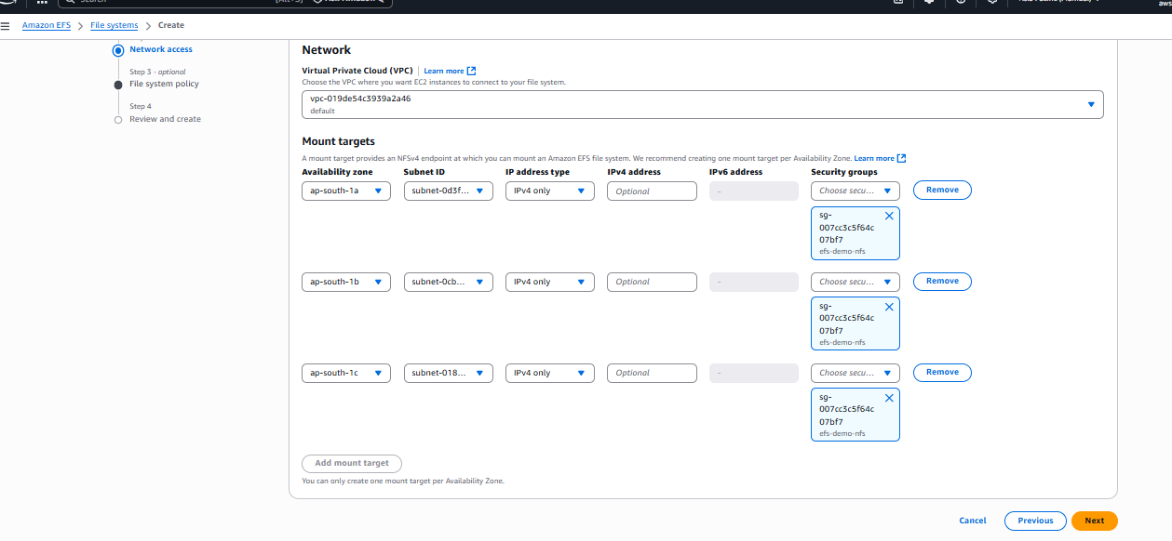
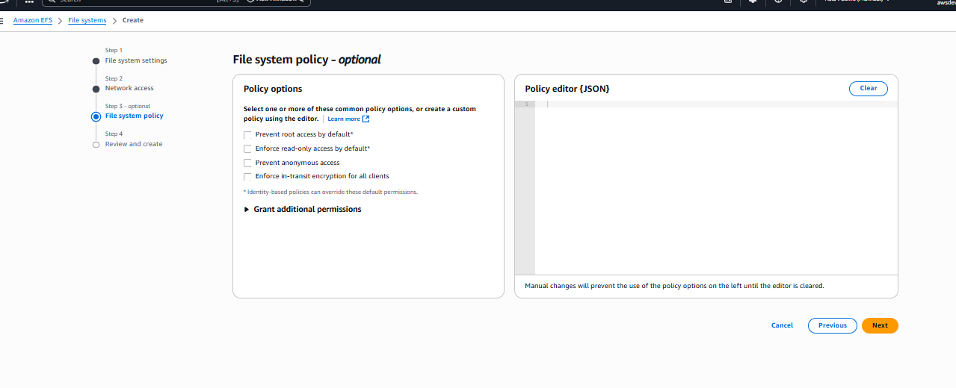
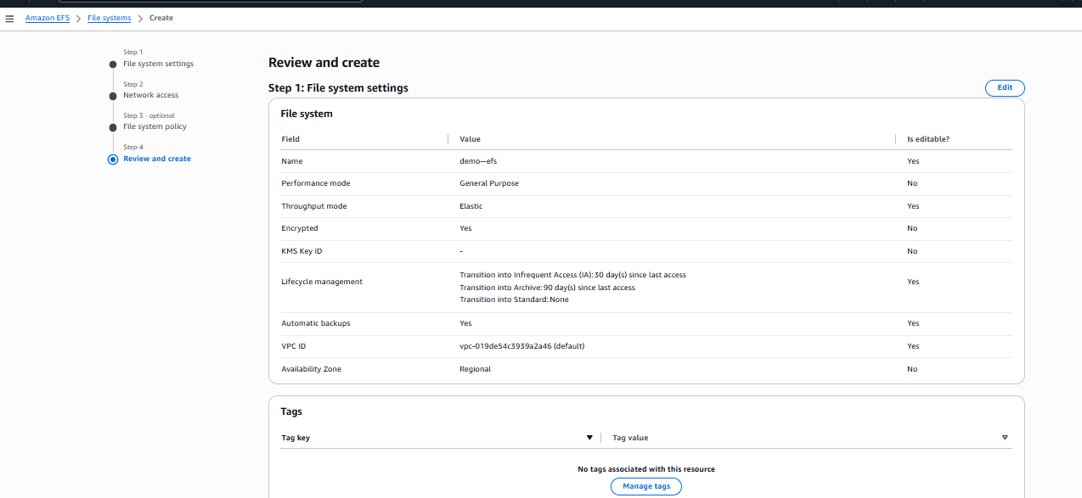
EFS has been created
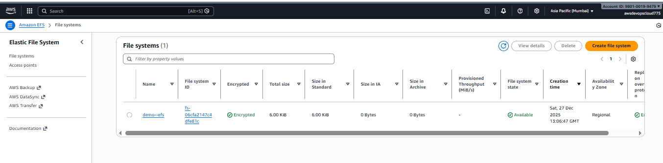
Now we need to mount EFS on EC2 instances
Need to create two EC2 instance, 1 Need to create ap-south-1a and 2nd need to create ap-south-1b

Two instance has been created
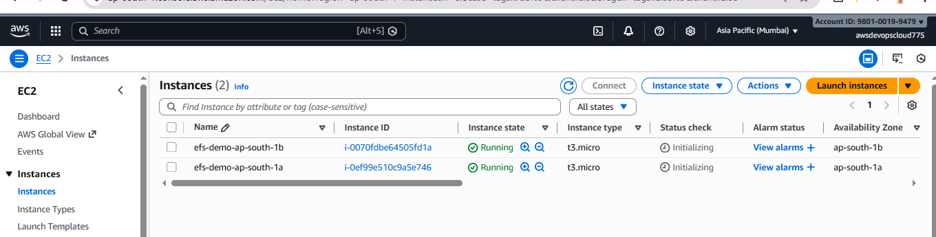

Need to change security group and reassign security group which we have created.
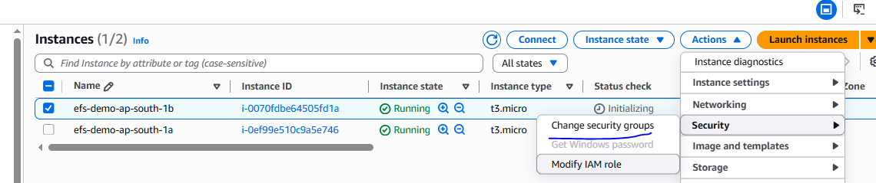
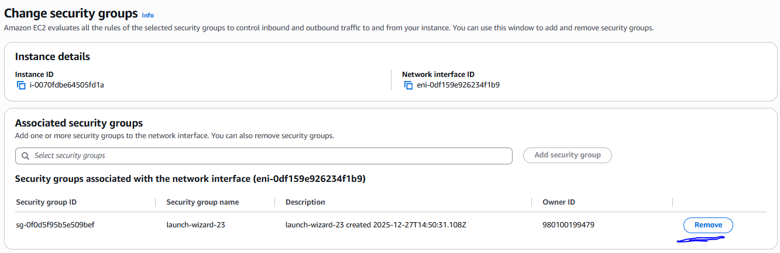
New security group assign
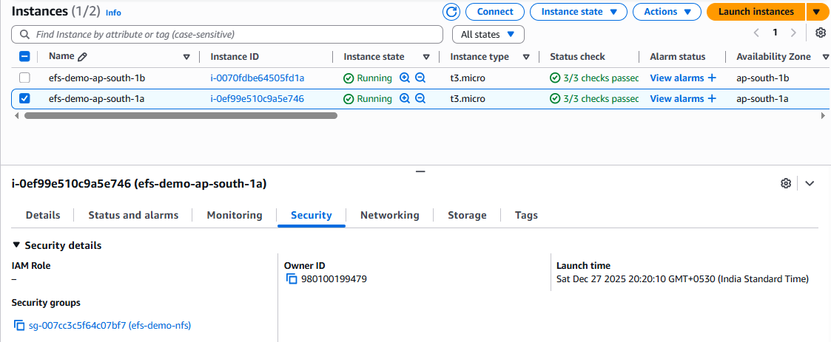
Login in the both server
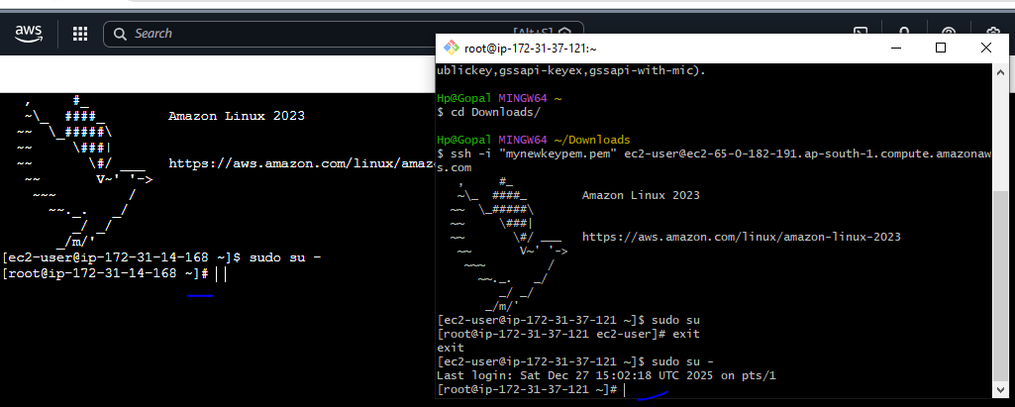

Attached EFS to the server
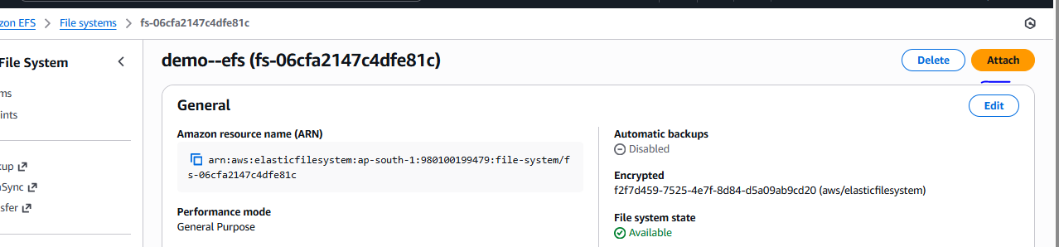
Need to copy highlighted link and mount on the server as mention below
